Tobacco-Free Earth Day 2015
Your Campus Name Here
Event Date, Time, Location
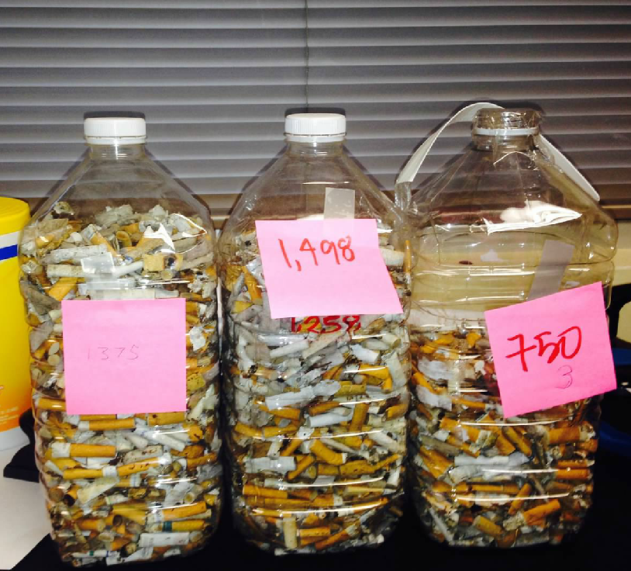
Each year, thousands of cigarettes butts are littered on college campuses.

Volunteer for a tobacco waste litter cleanup to celebrate to celebrate Earth Day.
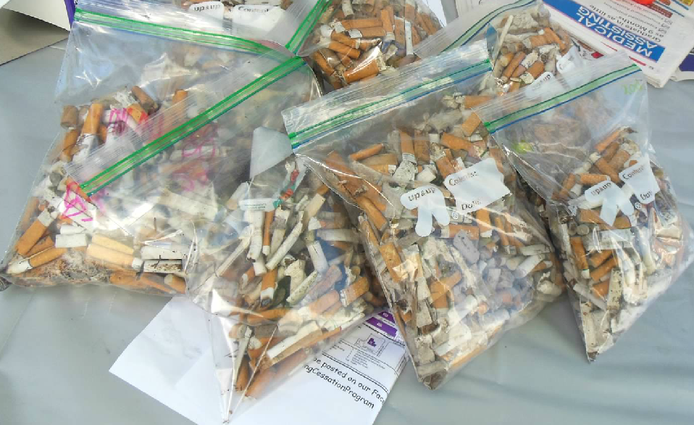

Event sponsor contact info & logo
Email, phone or web address

