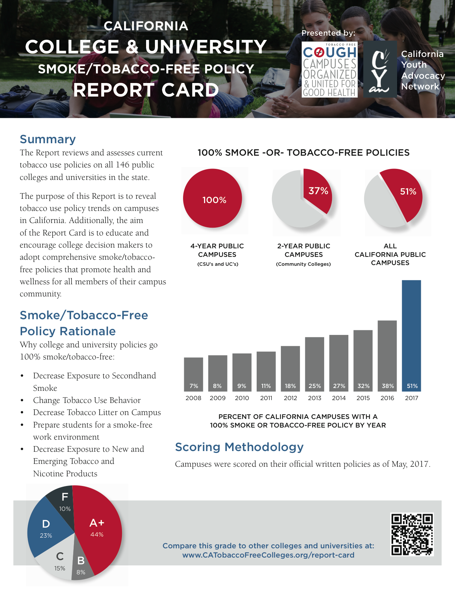

**ABC College or University Name**

**Score: 100, Grade: A+**